
REPUBLIC OF CAMEROON
PEACE-WORK-FATHERLAND
UNIVERSITY OF BUEA
FACULTY OF ENGINEERING AND TECHNOLOGY

DEPARTMENT OF COMPUTER ENGINEERING
CEF 440: INTERNET PROGRAMMING AND MOBILE PROGRAMMING

COURSE INSTRUCTOR: Dr. VALERY NKEMENI

TASK 6: Database Design and Implementation

Presented by: GROUP 20

NAME | MATRTICLE
TEBOH MANOIELLA | FE23A167
EBONG THIERRY | FE23A039
EBONG VALITINE | FE23A038
LUIGI-GONZAGA M. FONKENG | FE23A084

6.1 Introduction
CellScope is a crowdsensed cellular coverage intelligence platform designed to collect, store, synchronize, and analyse real-time mobile network signal measurements. Field engineers (technicians) use the application to conduct drive tests, capturing key network telemetry data at various geographic locations. The collected data is stored locally during offline operation and synchronised to a central cloud database when connectivity is available, enabling comprehensive network quality analysis and AI-powered diagnostic reporting.
This report documents the complete database design and implementation for the CellScope backend system. The backend is a full-stack TypeScript/Node.js application built with Express.js on the server side and a React + Vite frontend. It integrates two database technologies: a PostgreSQL relational database (accessed via the Drizzle ORM) for persistent structured storage, and Google Firebase Firestore as a complementary cloud document store supporting real-time synchronisation and mobile offline operation. Firebase Authentication provides identity management across both layers.
The report follows the structure prescribed by the Task 6 marking guidelines, addressing data elements, conceptual design, entity-relationship modelling, design decisions, normalisation, implementation, backend integration, security, and performance considerations.

6.2 Data Elements

6.2.1 What Data Does the System Need to Store?
CellScope collects two primary categories of data: user (engineer) profile data and cellular telemetry measurement data. Each category serves a distinct purpose within the system.

User / Engineer Data
Every individual who performs drive tests is registered as a user in the system. The following attributes are captured for each user:
Attribute | Purpose | Justification
id (serial) | Auto-incremented integer primary key | Uniquely identifies each user row in the relational database
uid | Firebase Authentication UID (text) | Links the local database record to the Firebase identity; used for token verification
email | Registered email address | Primary contact identifier; used for login and profile lookup
name | Full name of the engineer | Humanises records; used in reports and the UI
techId | System-generated technician code (e.g. 4821-K) | Provides a short, shareable identifier for field engineers
createdAt | Timestamp of account creation | Audit trail; tracks when the engineer was registered

Telemetry Log Data
Each telemetry log represents a single point measurement recorded during a drive test. The following attributes are captured:
Attribute | Data Type | Purpose
id | Text (Primary Key) | Unique identifier for each measurement record
batchId | Text | Groups measurements from a single drive-test session/batch
techId | Text | Identifies the technician who recorded the measurement
timestamp | Text (ISO datetime) | Records exactly when the measurement was taken
rsrp | Integer (dBm) | Reference Signal Received Power — primary signal strength metric
band | Text | Network band / generation (e.g., 4G LTE, 5G NR, 3G UMTS)
latitude | Double Precision (decimal degrees) | Geographic latitude for mapping the measurement location
longitude | Double Precision (decimal degrees) | Geographic longitude for mapping the measurement location
synced | Boolean | Indicates whether the record has been successfully uploaded to the cloud
pci | Integer | Physical Cell Identifier — identifies the specific cell tower serving the measurement
cellId | Text | Unique cell identifier string for the serving base station
userId | Integer (Foreign Key) | References the users table to associate a measurement with its engineer

6.2.2 Why Each Data Element Is Needed
The RSRP (rsrp) field is the most critical measurement field. Reference Signal Received Power is the standard 3GPP metric for evaluating LTE and 5G downlink signal quality. Values above -85 dBm indicate excellent coverage, -85 to -105 dBm indicates fair coverage, and below -105 dBm indicates poor coverage with likely service degradation. This value drives the coverage categorisation logic in the system's API endpoints.
The latitude and longitude pair enables all geospatial features of the system: the interactive coverage map, identification of poor-signal geographic zones, and targeted remediation recommendations from the AI diagnostic engine.
The synced boolean is the backbone of the offline-first architecture. When a measurement is recorded without internet connectivity, it is stored locally with synced set to false. The bulk synchronisation endpoint later marks these records as true once they have been uploaded.
The pci (Physical Cell Identifier) and cellId together allow engineers to attribute signal measurements to specific cell towers, which is essential for diagnosing whether coverage gaps are caused by a particular transmitter or a general area-wide deficiency.

6.3 Conceptual Database Design

6.3.1 Entities
Based on the system requirements, two primary entities were identified for the CellScope data model:

Entity 1: User
Represents a registered field engineer or technician who uses CellScope to conduct drive tests. A User has a unique identity anchored by their Firebase Authentication UID, a readable email address, a display name, a generated technician code (techId), and a registration timestamp. The User entity is the authoritative source of identity within the system.

Entity 2: TelemetryLog
Represents a single atomic network measurement captured at a specific geographic location and time. Each TelemetryLog encapsulates signal strength (RSRP in dBm), network band information, GPS coordinates, cell tower identifiers, and synchronisation status. The TelemetryLog is the core data product of the CellScope system.

6.3.2 Relationships Between Entities
The relationship between User and TelemetryLog is one-to-many (1:M):
- One User can create (collect) many TelemetryLogs over the course of multiple drive-test sessions.
- Each TelemetryLog belongs to at most one User (recorded via the userId foreign key).
- A TelemetryLog may also be recorded anonymously (userId is nullable), supporting use cases where measurements are imported without a linked engineer.

This relationship is enforced at the database level through a foreign key constraint on the telemetry_logs.user_id column, which references users.id.

6.3.3 Justification for Entity Choices
These two entities were selected because they directly reflect the two central real-world objects in the system: the person performing the measurement and the measurement itself. Separating them into distinct entities (rather than embedding engineer details in every measurement row) avoids data redundancy, simplifies updates to engineer profiles, and enables the system to efficiently query measurements by engineer or independently of any engineer.
A third entity, CoverageArea, was considered but not implemented as a formal table. Coverage area classification (Excellent / Fair / Poor) is computed dynamically at query time from the rsrp field rather than stored, since it is a derived attribute and storing it would risk inconsistency.

6.4 Entity-Relationship Diagram

6.4.1 Textual ER Representation
The following describes the Entity-Relationship structure of the CellScope database:

Entity | Attribute | Key Type | Data Type | Constraint
users | id | Primary Key | Serial (Integer) | NOT NULL, AUTO-INCREMENT
users | uid | Unique Key | Text | NOT NULL, UNIQUE
users | email |  | Text | NOT NULL
users | name |  | Text | NULLABLE
users | techId |  | Text | NULLABLE
users | createdAt |  | Timestamp | DEFAULT NOW()
telemetry_logs | id | Primary Key | Text | NOT NULL
telemetry_logs | batchId |  | Text | NULLABLE
telemetry_logs | techId |  | Text | NULLABLE
telemetry_logs | timestamp |  | Text | NULLABLE
telemetry_logs | rsrp |  | Integer (dBm) | NOT NULL
telemetry_logs | band |  | Text | NULLABLE
telemetry_logs | latitude |  | Double Precision | NOT NULL
telemetry_logs | longitude |  | Double Precision | NOT NULL
telemetry_logs | synced |  | Boolean | DEFAULT true
telemetry_logs | pci |  | Integer | NULLABLE
telemetry_logs | cellId |  | Text | NULLABLE
telemetry_logs | userId | Foreign Key → users.id | Integer | NULLABLE, ON DELETE SET NULL

6.4.2 Cardinality
The cardinality of the relationship is:
- users (1) → telemetry_logs (Many): One engineer can produce many measurements.
- telemetry_logs (Many) → users (1): Each measurement is linked to at most one engineer.

The relationship is optional on the telemetry_logs side (userId is nullable), meaning logs can exist without being associated to a specific user account. This was a deliberate design choice to accommodate bulk imports and anonymous measurements without violating referential integrity.

6.4.3 Firestore Document Model (Parallel Cloud Layer)
In parallel with the PostgreSQL schema, the Firestore document store mirrors a subset of this structure using two top-level collections:
Firestore Collection | Document Schema | Description
/users/{userId} | uid, email, name, techId, createdAt | Engineer metadata; document ID matches Firebase Auth UID
/logs/{logId} | id, rsrp, latitude, longitude, batchId, techId, band, pci, cellId, timestamp, synced | Immutable telemetry measurement; document ID matches the log id field

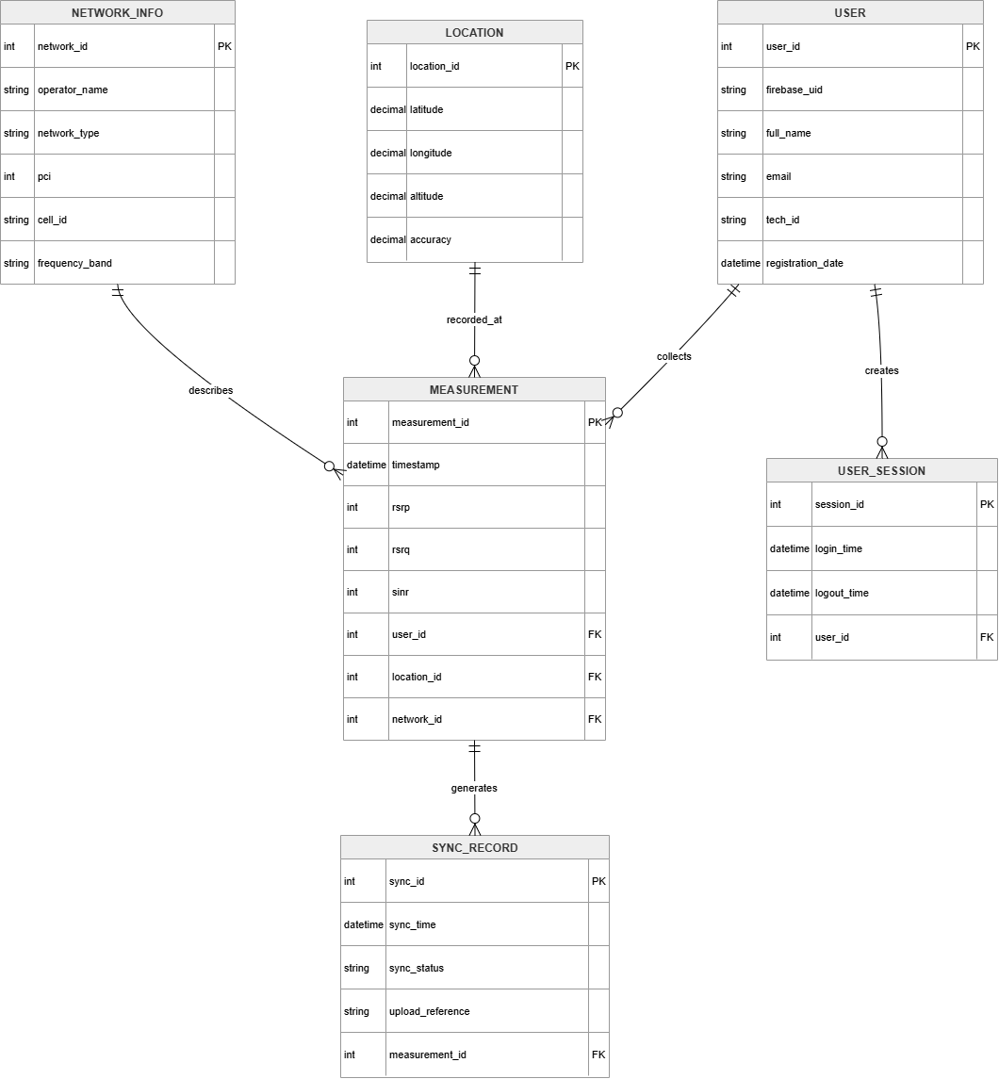

ER-Diagram

6.5 Database Normalization

6.5.1 First Normal Form (1NF)
The database satisfies 1NF because all attribute values in both tables are atomic (indivisible single values). There are no repeating groups or arrays stored in any column. For example, GPS coordinates are stored as two separate numeric columns (latitude, longitude) rather than as a composite string, and each row in telemetry_logs represent exactly one measurement event.

6.5.2 Second Normal Form (2NF)
Both tables satisfy 2NF. Since both tables use a single-column primary key (users.id is a serial integer; telemetry_logs.id is a text UUID), there are no partial dependencies possible. Every non-key attribute in both tables is fully dependent on the entire primary key of its respective table.
- In users: name, email, uid, techId, and createdAt are all properties of the specific user identified by id.
- In telemetry_logs: all measurement fields (rsrp, band, latitude, longitude, etc.) describe the specific measurement identified by its id.

6.5.3 Third Normal Form (3NF)
The schema satisfies 3NF because there are no transitive dependencies present:
- User details (name, email, techId) are stored once in the users table and not repeated in every telemetry_logs row. This eliminates the redundancy that would otherwise occur if engineer name or email appeared in every measurement record.
- The telemetry_logs table references user identity via userId (a foreign key to users.id), ensuring that engineer information is stored in exactly one place. If an engineer changes their name or email, only one row in users needs to be updated.
- The band (e.g., '5G NR', '4G LTE') is stored as a denormalised text string rather than as a foreign key to a separate bands lookup table. This is an accepted pragmatic decision since band identifiers are stable, short strings, and a separate table would add join complexity with negligible benefit.

Overall, the schema achieves Third Normal Form, which is the standard target for operational relational databases balancing query performance with data integrity.

6.6 Database Design Decisions

6.6.1 Why a Relational Database?
A relational database (PostgreSQL) was chosen as the primary persistent store for the following reasons:
- Structured data with clear, stable entity relationships — user-to-measurement is a well-defined one-to-many relationship that maps naturally to relational tables.
- Data integrity enforcement through foreign keys, NOT NULL constraints, and UNIQUE constraints prevents corrupt or duplicate records.
- SQL-based querying enables complex aggregation operations (average signal, count of poor-signal records, ordered retrieval) that are efficiently supported by PostgreSQL's query planner.
- Drizzle ORM provides type-safe query building in TypeScript, reducing the risk of SQL injection and runtime type errors.

6.6.2 Why PostgreSQL Specifically?
PostgreSQL was selected over alternatives such as MySQL or SQLite for the following reasons:
- The system is deployed on Google Cloud SQL, which offers first-class managed PostgreSQL support with automatic backups, failover, and scaling.
- PostgreSQL's doublePrecision column type provides the necessary numeric precision for GPS coordinate storage without rounding errors.
- The onConflictDoUpdate (upsert) capability is used extensively in the synchronisation engine to handle idempotent bulk uploads efficiently.

6.6.3 Why Drizzle ORM?
Drizzle ORM was chosen as the database access layer because it provides a TypeScript-native schema definition (schema.ts) that serves as a single source of truth for both the database structure and the TypeScript types used throughout the application. This eliminates the need for separate type definitions and database migration scripts that could diverge over time. Drizzle also generates type-safe query builders that catch errors at compile time rather than at runtime.

6.6.4 Why Firebase Firestore as a Parallel Store?
Firestore was included alongside PostgreSQL to satisfy specific requirements that a traditional relational database cannot address as effectively:
- Offline-first mobile support: Firestore's native offline persistence allows client-side applications to write measurements even when there is no internet connectivity, automatically syncing when connectivity is restored.
- Real-time listeners: Firestore supports real-time updates, enabling a future enhancement where the coverage map updates live as new measurements are uploaded.
- Firebase Authentication integration: Firebase Auth manages all user identity tokens, and Firestore security rules can directly reference auth.uid, creating a seamless access control layer without requiring custom session management.

6.6.5 Why Not Use a Mobile SQLite / Room Database Directly?
While Android's Room Database (which wraps SQLite) is commonly used for on-device local storage in Android apps, the CellScope backend is a web-based full-stack application rather than a native Android app. The system architecture uses a Node.js/Express server as the backend, which requires a server-side database. Firebase Firestore fulfils the offline/sync role that Room Database would play in a native Android context, while PostgreSQL on Cloud SQL provides the persistent, queryable backend store.

6.6.6 Dual-Database Architecture Summary
Aspect | PostgreSQL (Cloud SQL) | Firebase Firestore
Primary Role | Persistent structured storage, analytics, aggregation | Real-time sync, offline support, mobile access
Access Layer | Drizzle ORM via Express.js backend | Firebase SDK (client + admin)
Authentication | Not directly; handled by Firebase Auth on server | Native Firebase Auth integration via security rules
Offline Support | No (server-side only) | Yes (native client-side persistence)
Query Capability | Full SQL aggregation, joins, ordering | Limited; document-based queries
Deployment | Google Cloud SQL (managed) | Firebase project (managed)

6.7 Database Implementation

6.7.1 PostgreSQL Schema Implementation
The database schema is defined in src/db/schema.ts using Drizzle ORM's TypeScript schema builder. This file is the canonical definition of all table structures, column types, constraints, and inter-table relationships.

Users Table Implementation
export const users = pgTable('users', {
id: serial('id').primaryKey(),
uid: text('uid').notNull().unique(),
email: text('email').notNull(),
name: text('name'),
techId: text('tech_id'),
createdAt: timestamp('created_at').defaultNow(),
});

The users table uses a serial (auto-incrementing integer) as its internal primary key for efficient join operations. The uid column stores the Firebase Authentication UID as a secondary unique key, enabling lookups by both internal ID and external Firebase identity. The email column is marked NOT NULL, as a valid email is required for every account. The createdAt timestamp defaults to the current server time at insert, providing an automatic audit trail.

Telemetry Logs Table Implementation
export const telemetryLogs = pgTable('telemetry_logs', {
id: text('id').primaryKey(),
batchId: text('batch_id'),
techId: text('tech_id'),
timestamp: text('timestamp'),
rsrp: integer('rsrp').notNull(),
band: text('band'),
latitude: doublePrecision('latitude').notNull(),
longitude: doublePrecision('longitude').notNull(),
synced: boolean('synced').default(true),
pci: integer('pci'),
cellId: text('cell_id'),
userId: integer('user_id').references(() => users.id),
});

The telemetry_logs table uses a client-generated text string as its primary key, allowing the mobile/web client to assign identifiers before a network connection is established (a pattern required by offline-first architectures). The three required fields — rsrp, latitude, and longitude — are enforced as NOT NULL at the database level, matching the validation logic in the API endpoints. The userId foreign key references users.id; it is nullable to allow anonymous measurements.

ORM Relationships
export const usersRelations = relations(users, ({ many }) => ({
logs: many(telemetryLogs),
}));

export const telemetryLogsRelations = relations(telemetryLogs, ({ one }) => ({
user: one(users, {
fields: [telemetryLogs.userId],
references: [users.id],
}),
}));

Drizzle ORM's relations API declares the logical associations between tables. This enables type-safe eager loading (joining related data) in queries without writing raw SQL JOIN clauses.

6.7.2 Firestore Database Implementation
The Firestore database is defined in two parallel layers: the firebase-blueprint.json file (which documents the expected schema) and the firestore.rules file (which enforces it at runtime).

Firestore Collections and Document Schemas
Collection Path | Required Fields | Data Types
/users/{userId} | uid, email | uid: string, email: string, name: string (opt.), techId: string (opt.)
/logs/{logId} | id, rsrp, latitude, longitude | id: string, rsrp: int, latitude: number, longitude: number, band: string, etc.

Database Configuration
The PostgreSQL connection is configured via environment variables loaded from a .env file:
SQL_HOST = <Cloud SQL host address>
SQL_DB_NAME = <database name>
SQL_ADMIN_USER = <admin username>
SQL_ADMIN_PASSWORD = <admin password>

These credentials are injected at runtime by the deployment environment. The Drizzle configuration in src/db/drizzle.config.ts validates that all four environment variables are present at startup, throwing descriptive errors if any are missing.

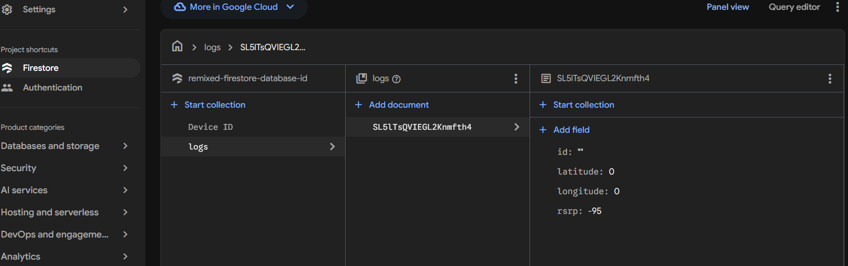

6.8 Backend Implementation

6.8.1 Architecture Overview
The backend is implemented as a TypeScript Express.js server (server.ts) that exposes a RESTful API. All database interactions are centralised in the Database class defined in server/db.ts. This class-based repository pattern separates business logic from database access concerns.

6.8.2 Database Class Methods (Repository Layer)
Method | Operation | Description
Database.getUser(email) | SELECT | Fetch a user profile by email address
Database.getUserByUid(uid) | SELECT | Fetch a user profile by Firebase UID; used for token-based authentication
Database.createUser(name, email, techId, uid) | INSERT ... ON CONFLICT DO UPDATE | Register a new engineer or update an existing profile (upsert pattern)
Database.getLogs() | SELECT (ordered) | Retrieve all telemetry measurements ordered by timestamp descending
Database.addLog(log, userUid) | INSERT ... ON CONFLICT DO NOTHING | Add a single measurement; resolves userId from userUid if provided
Database.bulkSyncLogs(newLogs, userUid) | INSERT ... ON CONFLICT DO UPDATE | Batch-insert multiple measurements, marking each as synced=true; idempotent
Database.clearAllData() | DELETE | Purge all telemetry records from the database (administrative operation)

6.8.3 API Endpoints
The server exposes the following REST API endpoints that interact with the database:
Method | Endpoint | Database Operation | Description
GET | /api/health | None | Server and database status check
POST | /api/auth/firebase-sync | getUserByUid, createUser | Link Firebase identity to PostgreSQL profile
POST | /api/auth/login | getUser | Local email-based login fallback
POST | /api/auth/register | getUser, createUser | Register a new engineer account
GET | /api/telemetry/logs | getLogs | Retrieve all telemetry measurements
POST | /api/telemetry/log | addLog | Submit a single measurement
POST | /api/telemetry/sync | bulkSyncLogs | Batch-upload and sync pending measurements
GET | /api/telemetry/stats | getLogs (computed) | Aggregated statistics: total, synced, pending, avg signal
GET | /api/telemetry/coverage | getLogs (mapped) | Coverage map points with quality labels (Excellent/Fair/Poor)
POST | /api/ai/optimize | getLogs (read-only) | AI diagnostic analysis via Gemini API
POST | /api/telemetry/reset | clearAllData | Purge all telemetry records

6.8.4 Signal Quality Classification Logic
The system applies the following RSRP-based classification logic in the /api/telemetry/coverage endpoint and the AI diagnostics engine:
RSRP Range (dBm) | Quality Label | Interpretation
>= -85 dBm | Excellent | Strong signal; full service expected
-85 to -105 dBm | Fair | Moderate signal; some degradation possible
< -105 dBm | Poor | Weak signal; dropped calls or data failures likely

6.9 Database–Backend Integration

6.9.1 How the Application Saves Data
The data flow for saving a new measurement follows these steps:
- Step 1 — Client submits a POST request to /api/telemetry/log with measurement fields in the JSON body.
- Step 2 — The Express server validates that the required fields (rsrp, latitude, longitude) are present.
- Step 3 — Default values are applied for optional fields (e.g., band defaults to '5G NR', pci defaults to 312).
- Step 4 — Database.addLog() is called, which executes an INSERT ... ON CONFLICT DO NOTHING statement via Drizzle ORM.
- Step 5 — If a userUid is provided, the method first resolves the corresponding integer userId by querying the users table.
- Step 6 — The inserted log is returned to the client with a 201 Created status.

6.9.2 Offline-to-Cloud Synchronisation Flow
The offline synchronisation architecture works as follows:
- When the client has no internet connection, measurements are stored locally (in browser localStorage or Firestore offline cache) with synced = false.
- When connectivity is restored, the client collects all unsynced records and sends them as a batch to POST /api/telemetry/sync.
- The server calls Database.bulkSyncLogs(), which iterates through the batch and performs an upsert for each record:
.onConflictDoUpdate({ target: telemetryLogs.id, set: { synced: true } })
- Records that already exist in the database (from a previous partial sync) have their synced flag updated to true without creating duplicates.
- Records that do not yet exist are inserted with synced = true, since by the time they reach the server they are, by definition, in sync.

This upsert pattern ensures the synchronisation operation is fully idempotent: it can be safely retried multiple times without causing data corruption or duplicate entries.

6.9.3 What Happens When There Is No Internet?
When the client is offline:
- Firebase Firestore's native offline persistence stores new measurement documents in a local cache on the client device.
- The local database (managed by the Firestore SDK) queues write operations and retries them automatically when connectivity is restored.
- The synced field is set to false on all locally-created records, flagging them as pending synchronisation.
- The user interface remains fully functional, as all read operations are served from the local cache.

6.9.4 What Happens When Internet Returns?
When connectivity is restored:
- Firestore automatically flushes its pending write queue to the cloud, completing the document-level sync.
- The client application can additionally call POST /api/telemetry/sync to ensure all pending records are also persisted in the PostgreSQL database.
- The server marks all successfully uploaded records with synced = true in PostgreSQL.
- The statistics endpoint (/api/telemetry/stats) is updated to reflect the new counts of synced versus pending records.

6.10 Security Considerations

6.10.1 User Authentication
CellScope uses Firebase Authentication as its identity provider. The system supports:
- Google OAuth sign-in (via GoogleAuthProvider in the client SDK).
- Email/password authentication as a fallback.
- Firebase ID tokens (JWT) are issued upon successful authentication and must be included as a Bearer token in the Authorization header for protected API endpoints.

6.10.2 Server-Side Token Verification
The requireAuth middleware (src/middleware/auth.ts) protects sensitive endpoints by verifying Firebase ID tokens on the server side:
const decodedToken = await adminAuth.verifyIdToken(token);
The Firebase Admin SDK is used (not the client SDK) to verify tokens, ensuring that token validation happens in a trusted server environment. If a token is missing, malformed, or expired, the server returns a 401 Unauthorized response. Verified token claims (uid, email, name) are attached to the request object for downstream use.

6.10.3 Firestore Security Rules
The Firestore database is protected by a comprehensive set of security rules defined in firestore.rules:
- Default-deny policy: The catch-all rule match /{document=**} { allow read, write: if false; } blocks all access unless explicitly permitted by a more specific rule.
- User isolation: Users can only read, create, update, or delete their own profile document (isOwner check: request.auth.uid == userId).
- Field validation: The create rule for /users/{userId} enforces that uid and email are always present, email is a string no longer than 256 characters, and no more than 6 fields exist in the document.
- Telemetry immutability: The update and delete operations on /logs/{logId} are explicitly set to false, making telemetry records immutable audit trails once written.
- Authenticated read access: Any signed-in user can read telemetry logs, enabling the shared coverage map feature.

6.10.4 Sensitive Data Protection
Database credentials (SQL_HOST, SQL_ADMIN_USER, SQL_ADMIN_PASSWORD) are stored as environment variables and are never committed to the source repository (protected by .gitignore on .env files). The Firebase Admin SDK uses the project ID from a configuration file without embedding private keys in the source code, relying on Google Cloud's Application Default Credentials for server-side authentication in production.
The Gemini AI API key is managed via a secure secrets panel (Google AI Studio secrets injection) and is never included in the application source or build artefacts.

6.11 Testing and Validation

6.11.1 API Endpoint Validation
Each API endpoint includes input validation before any database operation is attempted. The validation strategy for key endpoints is as follows:
Endpoint | Validation Applied | Error Response
POST /api/telemetry/log | rsrp, latitude, longitude must be present | 400 Bad Request with descriptive error
POST /api/telemetry/sync | logs must be an array | 400 Bad Request if payload is not an array
POST /api/auth/register | name, email, password all required | 400 Bad Request with field specification
POST /api/auth/login | email and password required | 400 Bad Request
POST /api/auth/firebase-sync | Firebase Bearer token required | 401 Unauthorized via requireAuth middleware

6.11.2 Conflict and Duplicate Handling
The database implementation handles duplicate data scenarios through two distinct conflict resolution strategies:
- User registration (createUser): Uses ON CONFLICT DO UPDATE targeting the uid column. If a user with the same Firebase UID already exists, the email, name, and techId are updated to reflect any changes. This ensures user profile data stays current across multiple login sessions.
- Telemetry synchronisation (bulkSyncLogs): Uses ON CONFLICT DO UPDATE targeting the id column, updating only the synced field. This allows the same measurement to be submitted multiple times without creating duplicates, while ensuring the synced flag is always set to true after a successful server-side sync.
- Single log submission (addLog): Uses ON CONFLICT DO NOTHING. If a measurement with the same id already exists, the duplicate insertion is silently ignored, preventing any modification of existing data.

6.11.3 Error Handling
All database operations are wrapped in try-catch blocks. When a database error occurs, a descriptive error message is logged to the server console and a structured error response is returned to the client with an appropriate HTTP status code (400 for client errors, 500 for server/database errors). This prevents raw database error messages or stack traces from being exposed to the client.

6.11.4 Health Check
The /api/health endpoint provides a simple liveness probe that confirms the server is running. It returns the current timestamp, the service name (CellScope-Crowdsensed-Server), and the database type (PostgreSQL-CloudSQL-Active). This endpoint can be used by deployment infrastructure (load balancers, uptime monitors) to verify the service is operational.

6.12 Performance Considerations

6.12.1 Why Store Data Locally First?
The offline-first architecture, where measurements are stored locally before being synced to the server, provides three key performance benefits:
- Faster writes: Local writes complete immediately without waiting for a network round-trip, providing an instant response to the user during data collection.
- Network resilience: In areas with poor cellular coverage (which is precisely the use case for CellScope), network requests may time out or fail. Local storage ensures no data is lost during collection.
- Reduced server load: Measurements can be batched and submitted in a single bulk sync request rather than sending one HTTP request per measurement, significantly reducing the number of API calls and database transactions.

6.12.2 Idempotent Bulk Synchronisation
The bulkSyncLogs function's use of ON CONFLICT DO UPDATE (upsert) makes the synchronisation process idempotent. If a sync operation fails partway through (e.g., due to a network interruption), the client can safely retry the entire batch without causing duplicate records. This is a critical performance and reliability feature for a system operating in variable connectivity conditions.

6.12.3 Ordered Retrieval
The getLogs() method retrieves records ordered by timestamp descending:
.orderBy(desc(telemetryLogs.timestamp))
This ensures that the most recent measurements are returned first, which is the expected ordering for both the log display UI and the AI diagnostics engine (which uses the first 15 records as its analysis sample).

6.12.4 Large Dataset Handling
For future scalability, the system architecture supports the following optimisation strategies:
- Database-level indexing: PostgreSQL indexes can be added to frequently queried columns (userId, synced, timestamp) to accelerate filtering and ordering operations as the telemetry dataset grows.
- Pagination: The getLogs() API can be extended with LIMIT/OFFSET clauses or cursor-based pagination to avoid loading the entire measurement dataset in a single query.
- Aggregation at query time: The /api/telemetry/stats endpoint computes aggregate statistics (total count, synced count, average RSRP) from the raw data in application code. For very large datasets, these computations should be pushed to SQL-level GROUP BY and AVG() aggregation functions to reduce memory usage on the server.
- Batch processing: The bulk sync endpoint processes up to thousands of records in a single transaction, which is more efficient than individual inserts for high-volume synchronisation scenarios.

6.13 Summary
CellScope implements a robust, dual-database architecture designed for the specific demands of a crowdsensed cellular coverage measurement system. The design balances the competing requirements of structured data integrity, offline operation, real-time synchronisation, and AI-powered analytics.

Design Aspect | Solution Implemented
Primary Persistent Store | PostgreSQL (Google Cloud SQL) via Drizzle ORM
Cloud Document Store / Offline Sync | Firebase Firestore with offline persistence
Authentication | Firebase Authentication (Google OAuth + Email/Password)
Server Framework | Node.js + Express.js (TypeScript)
Schema Definition | Drizzle ORM schema.ts — single source of truth for types and structure
Normalisation Level | Third Normal Form (3NF) — no redundancy, no transitive dependencies
Referential Integrity | Foreign key: telemetry_logs.userId → users.id
Conflict Resolution | Upsert (ON CONFLICT DO UPDATE) for sync; DO NOTHING for deduplication
Access Control | Firebase JWT verification middleware + Firestore security rules
Performance Strategy | Offline-first local caching, batch synchronisation, ordered retrieval
AI Diagnostics | Google Gemini 2.5 Flash API with structured telemetry summary prompts

The schema achieves Third Normal Form while remaining pragmatic — the band field is stored as a denormalised text attribute rather than a foreign key, accepting a minor trade-off in favour of query simplicity. The dual-database approach effectively addresses the challenge of building a system that must be both reliable in offline conditions and analytically powerful when connected.
The Firestore security rules enforce a default-deny policy with fine-grained per-collection access controls, and telemetry logs are treated as immutable records once written, supporting their use as an audit trail for network quality measurements. Together, these design choices produce a system that is secure, scalable, and aligned with the operational realities of field-based cellular network testing.

